

Human Computer Interaction

**Group Project**

**Group Members**

|  |  |
| --- | --- |
| **Name** | **Roll numbers** |
| Rimsha | Bsef20a001 |
| Ayesha | Bsef20a007 |
| Neha | Bsef20a026 |
| Aiza | Bsef20a036 |



**Question.1**

**Refine your idea**

**Scope**

**Offer different ride types:**

In addition to taxi rides, the app could offer different ride types, such as luxury cars, SUVs, or vans. This would appeal to users with different needs and budgets.

**Offer different payment options**:

 The app could offer different payment options, such as cash, credit card, or mobile payments. This would make it more convenient for users to pay for their rides.

**Offer customer support in multiple languages:**

 The app could offer customer support in multiple languages to make it accessible to users from all over the world.

**Feasibility**

Feasibility of Ride Hailing App is given below:

1. **Ease of use:**

The app can be easily downloaded and installed on smartphones, making it accessible to a large number of people. The user-friendly interface of the app enables riders to use it with ease, and drivers can navigate through the app to find riders looking for a ride.

1. **Convenience:**

The app provides convenience to both riders and drivers. Riders can request rides from anywhere and at any time, and drivers can earn money on their own schedules. Convenience: The app provides convenience to both riders and drivers. Riders can request rides from anywhere and at any time, and drivers can earn money on their own schedules.

1. **Safety:**

Safety features such as GPS tracking, driver ratings, and in-app safety measures ensure the safety of riders and drivers. The app also maintains a record of all transactions, which adds another layer of security to the process.

1. **Cost-effective:**

The app provides affordable transportation solutions as drivers can offer rides at competitive rates, eliminating the need for expensive taxi services.



**Question.2**

**Identify target audiences**

The target audience for our project are:

**Commuters**: People who need to travel regularly to work or school and require a convenient and reliable transportation option.

**Travelers**: People who need a ride to and from the airport, hotel, or other locations while traveling.

**Nightlife enthusiasts**: People who are looking for a safe and convenient way to travel to bars, clubs, or other nightlife spots.

**Elderly and disabled people:** People who require special assistance or vehicles to travel due to physical limitations.

**Tourists:** People who are visiting a new city and require transportation to visit tourist attractions and explore the local area.

**Business travelers**: People who need a professional and reliable transportation option for business meetings or events.

These are just some of the most common demographics that use ride-hailing apps. The target audience can also be further segmented by age, income level, location, and personal preferences.

**Personas**

**Persona:1**

**Name**: Sarah

**Age**: 25

**Occupation**: Software Engineer

**Location**: Sheikhupura

**Goals**: To explore the city and experience all that it has to offer.

Sarah is a young, tech-savvy woman who is visiting Lahore for the first time. She is not familiar with the city and its transportation system, so she is looking for a reliable and convenient way to get around. She has heard about ride-hailing apps and is considering using one to get around the city.

**Pain points:** Not familiar with the city and its transportation system

Sarah's pain points are that she is not familiar with the city and its transportation system. She is also concerned about safety and security when using a ride-hailing app. She wants to make sure that she is using a reputable app that has a good safety record.

**Needs:** A reliable and convenient way to get around

Sarah's needs are for a ride-hailing app that is easy to use, has a good reputation, and offers competitive pricing. She also wants an app that allows her to track her ride in real time and provides her with information about the driver and the car.

**Preferences:** A ride-hailing app that is easy to use, has a good reputation, and offers competitive pricing

Sarah's preferences are for an app that is user-friendly and has a good design. She also wants an app that offers a variety of payment options, such as credit card, debit card, and cash



**Persona:2**

**Name**: Izal

**Age**: 35

**Gender**: Female

**Disability**: Cerebral palsy

**Occupation**: Software engineer

**Location**: Lahore

**Goals**

To get around the city easily and independently.

To feel safe and secure when using the app.

To be able to use the app in a way that is consistent with their disability.

**Needs**

Ability to book a ride using voice commands

Ability to see the vehicle's location and ETA in real time

Ability to request a wheelchair-accessible vehicle

Ability to cancel a ride without penalty

Ability to contact customer support if needed.

**Pain Points**

Has difficulty using ride-hailing apps that are not designed with accessibility in mind.

May have trouble finding the "Book a Ride" button.

May not be able to see the vehicle's location or ETA.

May not be able to cancel a ride without penalty.

May not be able to contact customer support if needed.

**Preferences**

Prefers to use the app on a smartphone or tablet.

Prefers to use the app in a quiet environment.

Prefers to use the app with a headset or ear buds.

**Persona:3**

**Name**: Maria

**Age**: 60

**Occupation**: Housewife

**Education**: Illiterate

**Income**: Low

**Location**: Lahore

**Goals**:

Maria's goal is to be able to get around more easily and independently.

She wants to be able to visit her daughter more often.

She wants to be able to go to the market and run errands



**Needs**:

Maria needs a way to get around that is affordable and accessible.

She needs a way to communicate with the driver, even if she doesn't speak English.

She needs a way to find the right place to pick up or drop off the car.

**Pain points:**

Maria's pain point is that she is illiterate and doesn't speak English.

She is worried about being able to use the app and communicate with the driver.

She is worried about getting lost or not being able to find the right place to pick up or drop off the car.

**Preferences**:

Maria prefers to use a ride-hailing app that is easy to use and understand.

She prefers an app that has a voice-activated feature so she can give instructions without having to read.

She prefers an app that has a translation feature so she can communicate with the driver.

**Scenarios**

**Scenario 1: A working mother in a rush**

A busy mother has just finished her shift at work and needs to get home quickly to pick up her children from school. She uses the ride-hailing app to request a ride and chooses the option for a child seat. The driver arrives promptly, helps her with the child seat, and drives her home safely.

**Scenario 2: Group outing**

A group of friends want to go out for a night on the town together and use the ride-hailing app to request a ride for multiple passengers. The driver arrives with a spacious vehicle that can accommodate everyone, and the group can enjoy a comfortable ride together.

**Scenario 3: Illiterate person**

An illiterate person wants to visit a friend who has moved to a new location they are not familiar with. They use the ride-hailing app to request a ride. The app has an option for a voice command, which they use to enter their desired destination. The driver arrives, helps them get in the car, and takes them to their desired location efficiently.

**Scenario 4: Disabled person**

A disabled person needs a ride to a doctor's appointment and uses the ride-hailing app to request a ride for a disabled person. The driver arrives in a vehicle that is wheelchair accessible and helps the person into the car and buckle in their seatbelt safely. During the ride, the driver ensures the person is comfortable and helps them to exit the car when they reach their destination.



**Scenario 5: An elderly couple and medical appointment**

An elderly couple with limited mobility requests a ride to a medical appointment. The app matches them with a driver who has a wheelchair-accessible vehicle. Upon arrival, the driver greets the couple and helps them into the vehicle. The driver secures the wheelchair and ensures the passenger is comfortable. Along the way, the driver makes sure the temperature and music selection are comfortable and answers any questions the passenger has. The ride ends without incident and the couple thanks the driver for the excellent service.

**Scenario 6: Solo female passenger**

A solo female passenger requests a ride to a remote location at night. The app sends a notification to the driver, who reviews the details and accepts the ride. The passenger is notified of the driver's name, car make and color, and license plate number. The driver arrives at the pickup location and confirms the passenger's identity before proceeding. Along the way, the driver offers a bottle of water and asks the passenger if the temperature and music selection are comfortable. The ride ends without incident and the passenger rates the driver 5 stars.

**Scenario 7: Late for a meeting**

A busy executive has an important meeting where they need to make a presentation. They use the ride-hailing app to request a ride and ask the driver to use the quickest route. The driver takes them there on time and helps carry the presentation materials to the meeting room.



**Question.3**

**Questionnaire**

We prepare questionnaire on Ride Hailing App and the link of questionnaires is given below:

<https://docs.google.com/forms/d/e/1FAIpQLSfZmE7JvrOTuc4GH4_5_jgF7S1aiJ1DhcgIIyli-D9gUjMZpQ/viewform?usp=pp_url>

We send this link to multiple people and receive following number of responses:

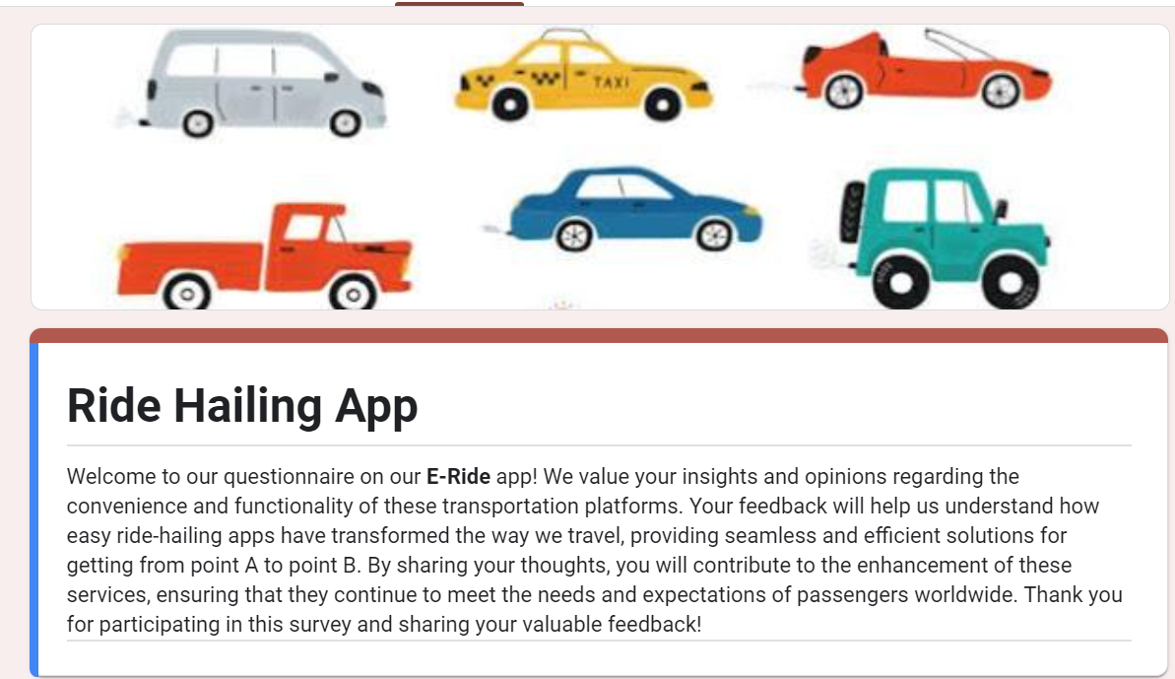

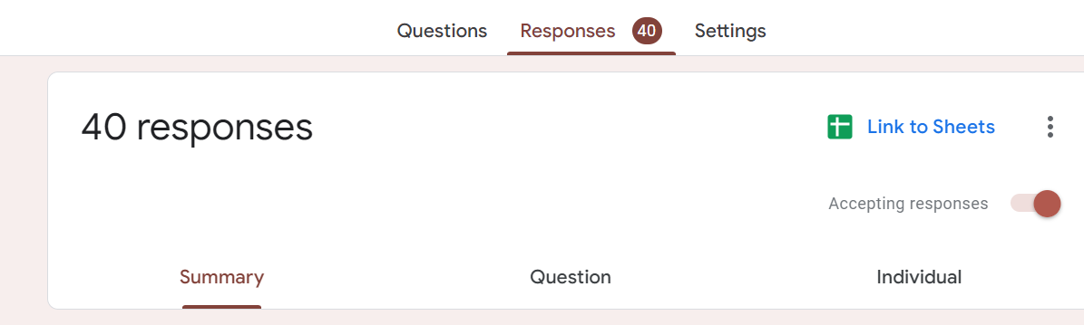

**Question.6**

**Interviews**



**Question.5**

**Analyze Data**

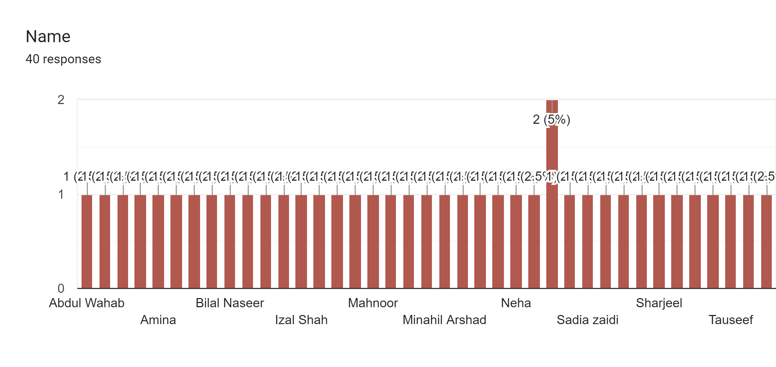

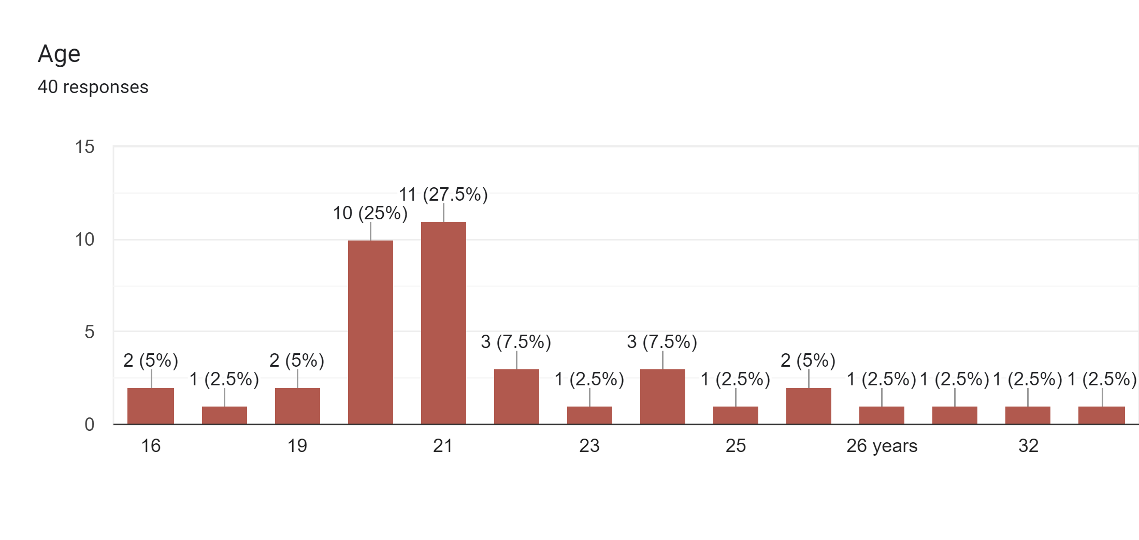

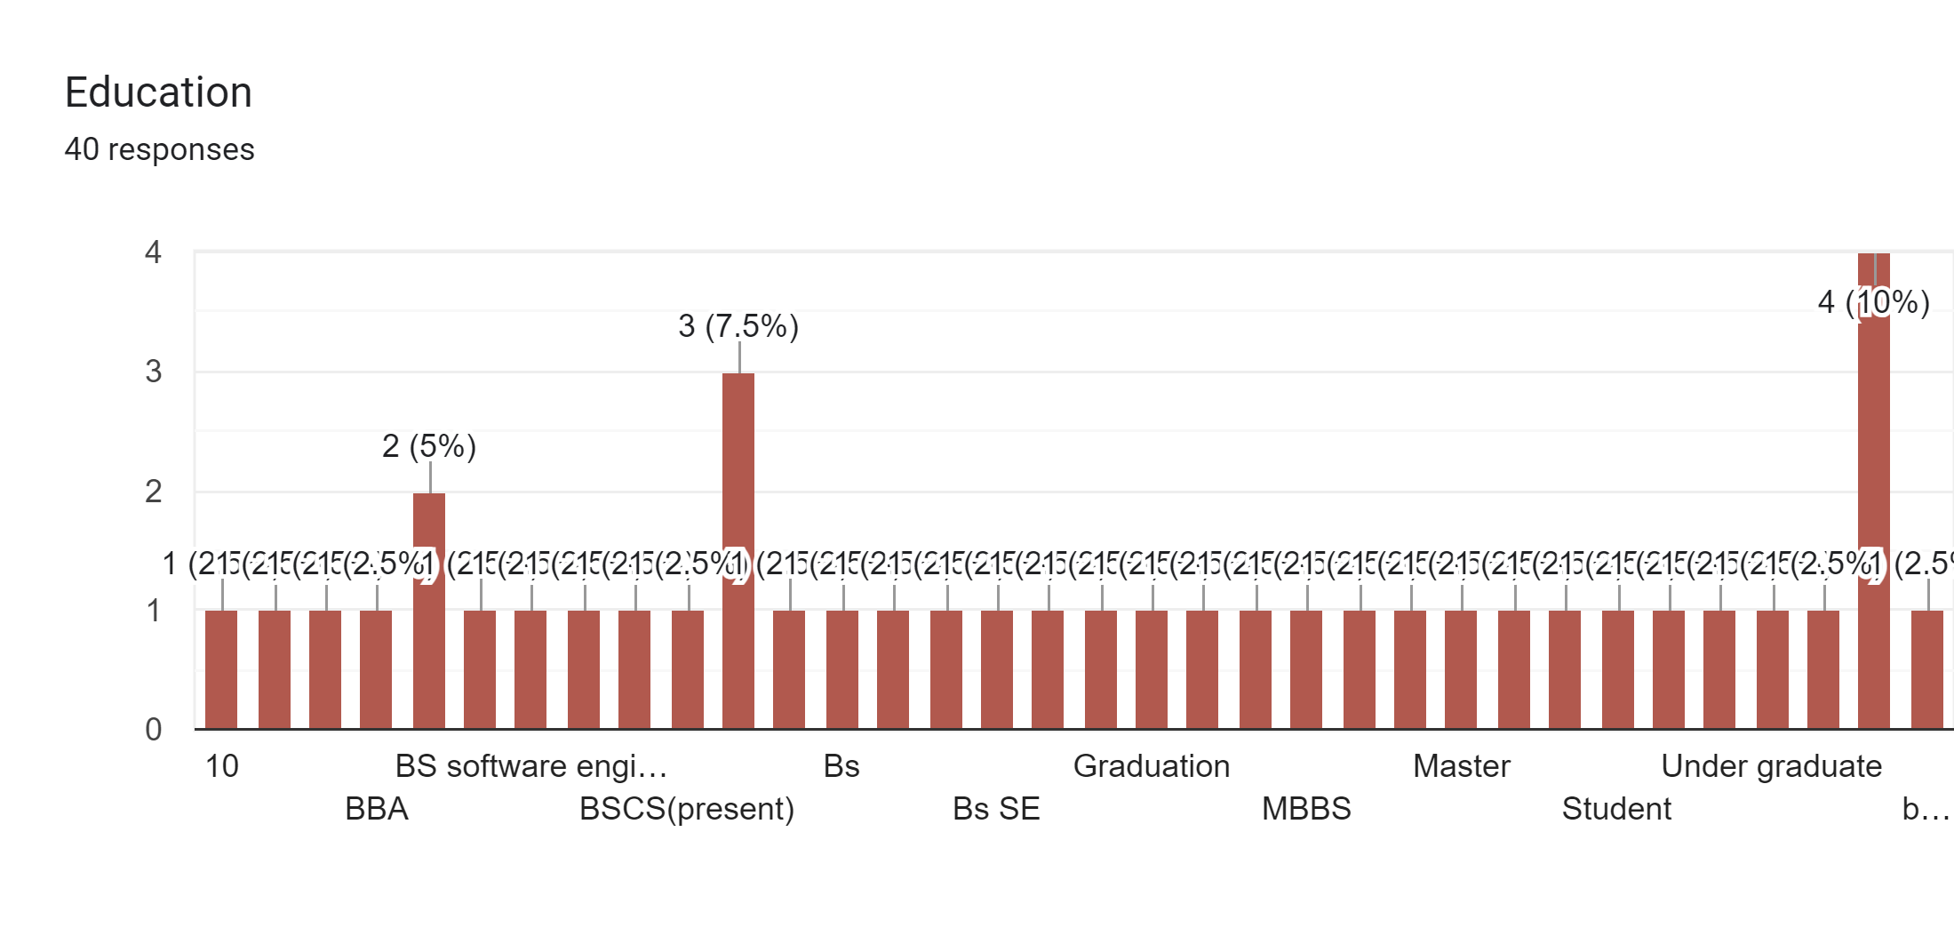





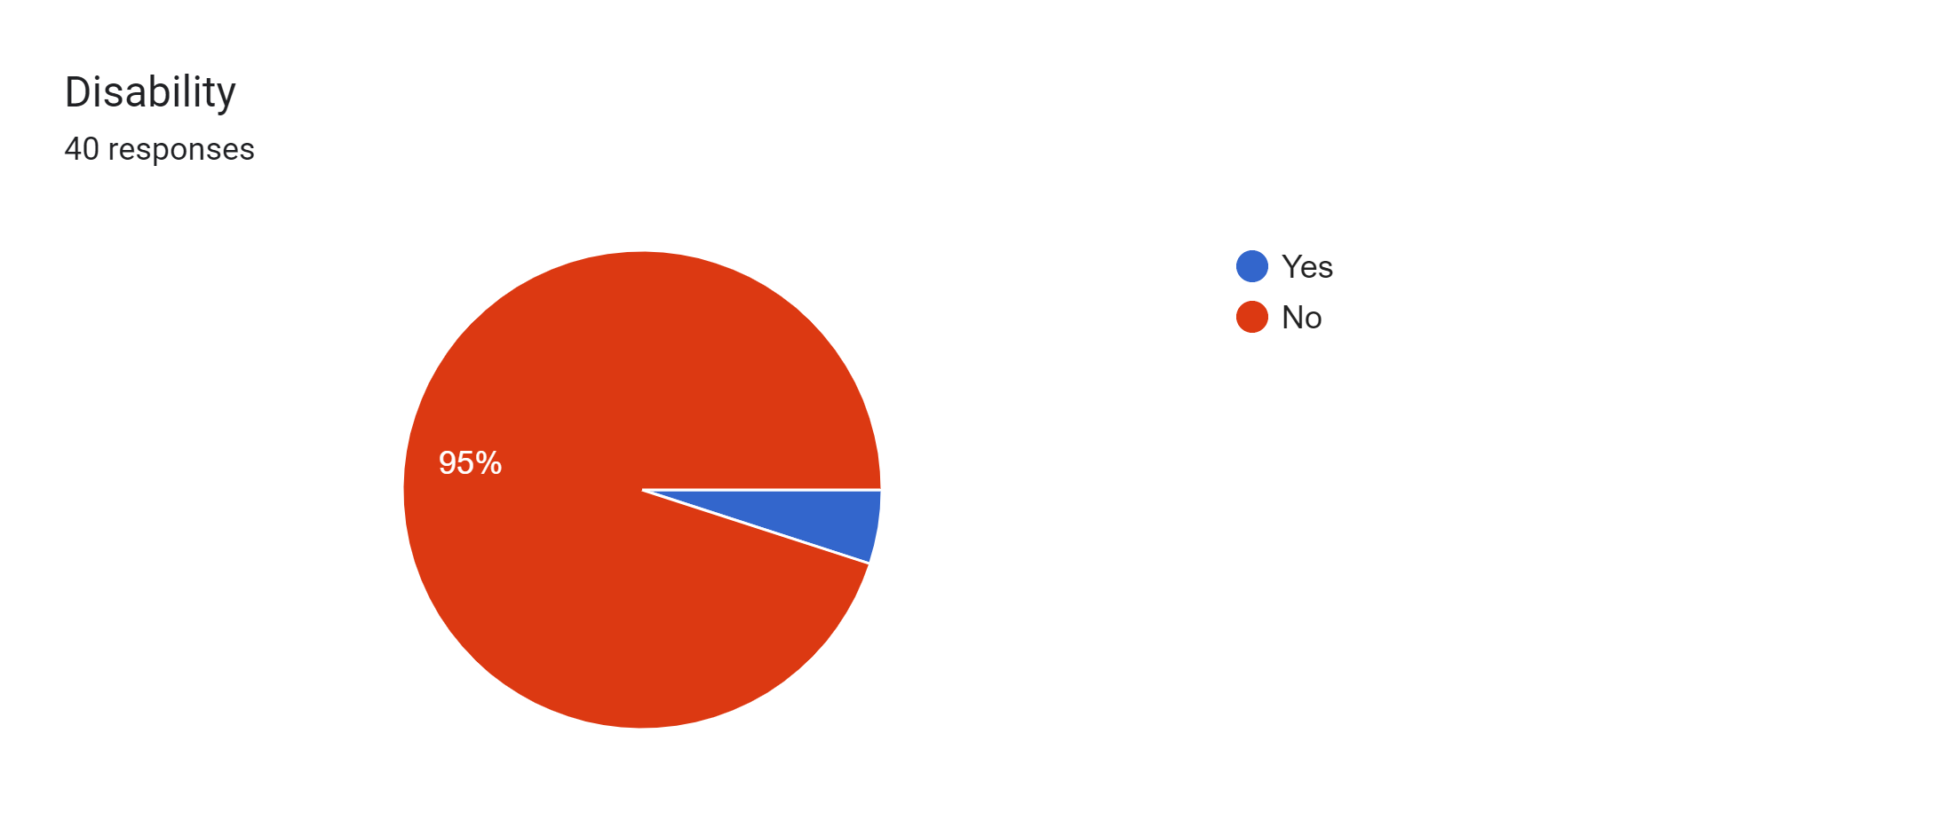



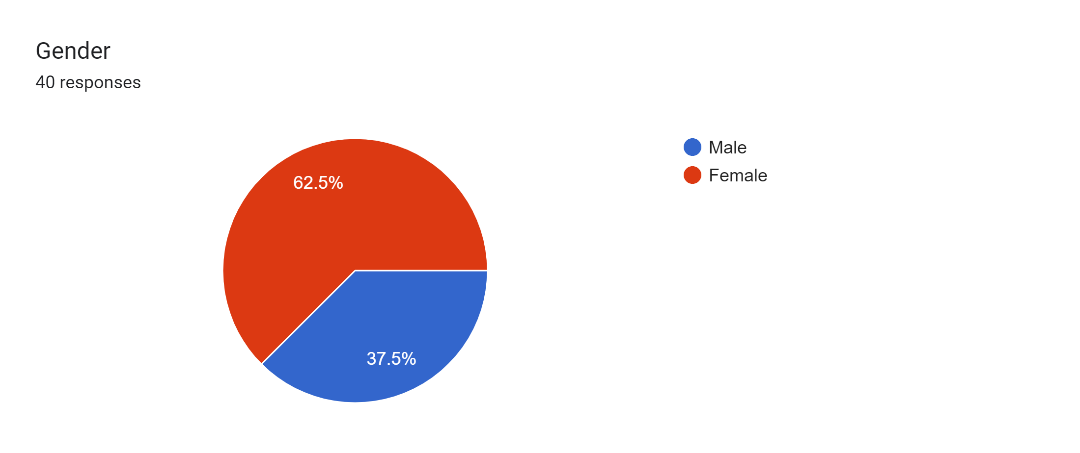

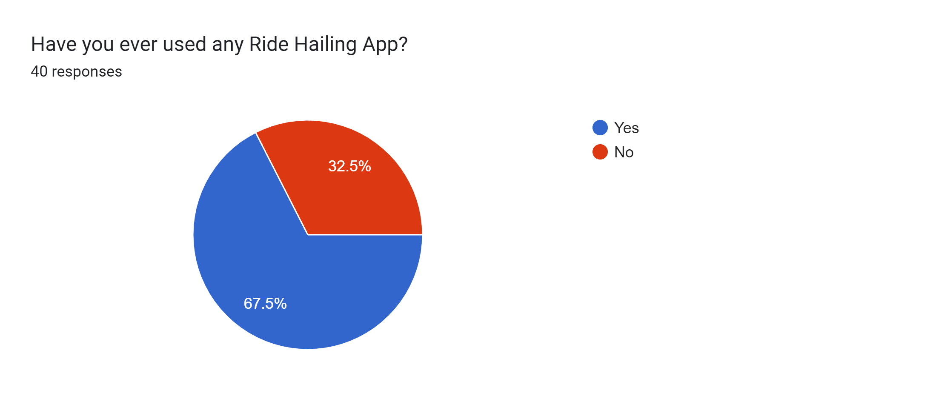



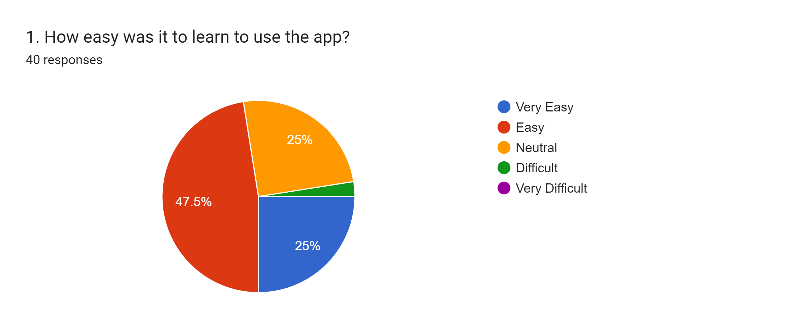

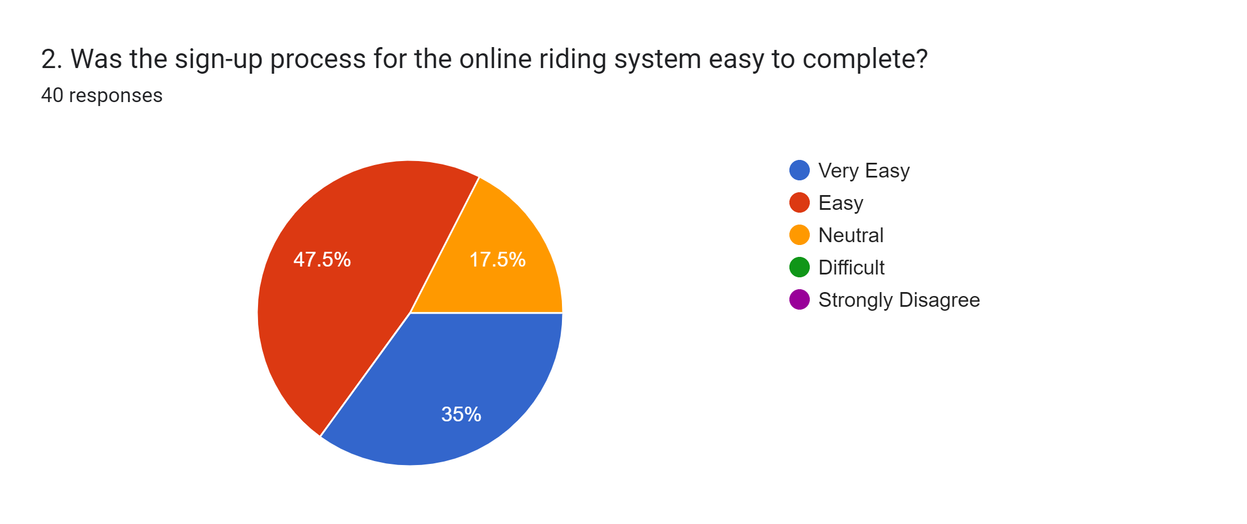



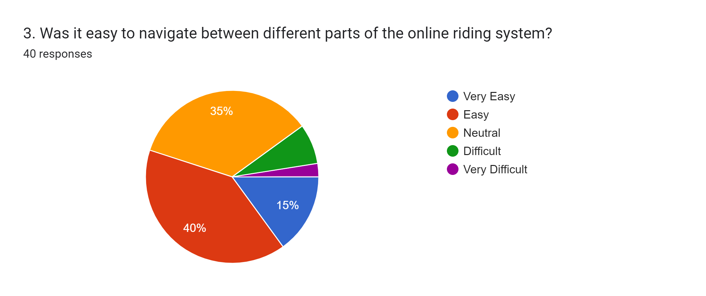

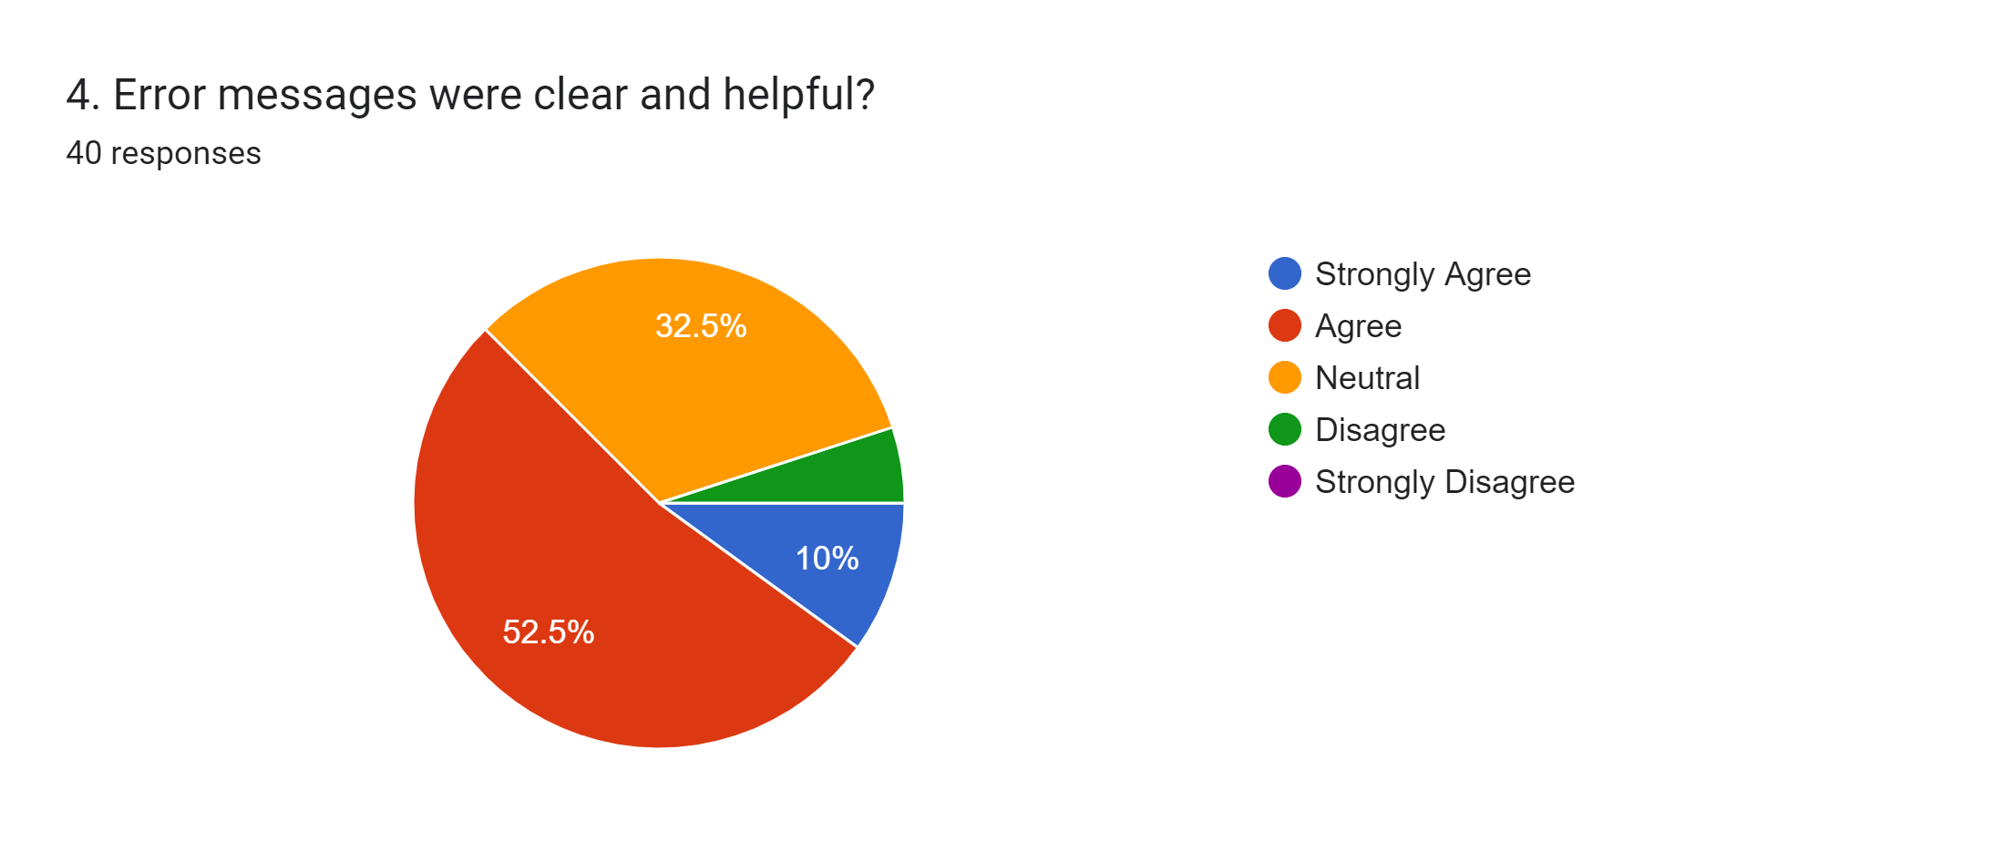



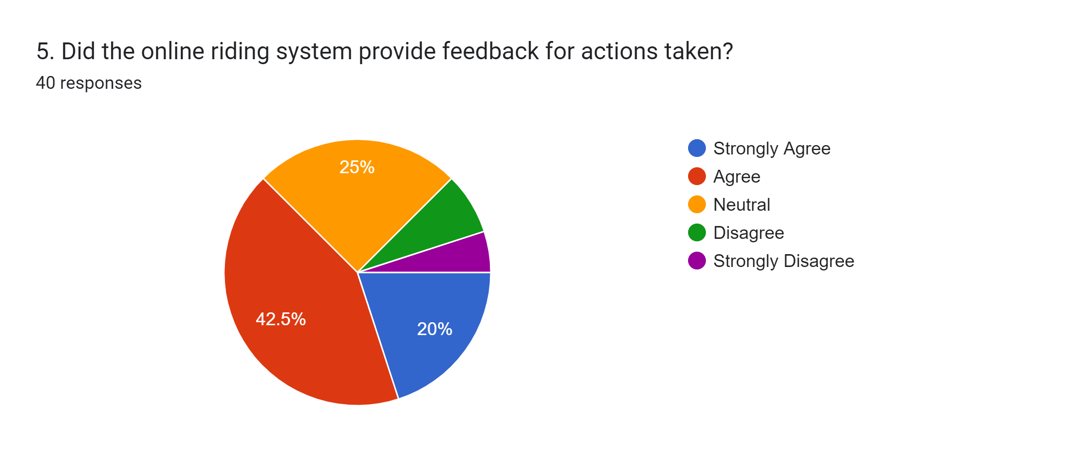

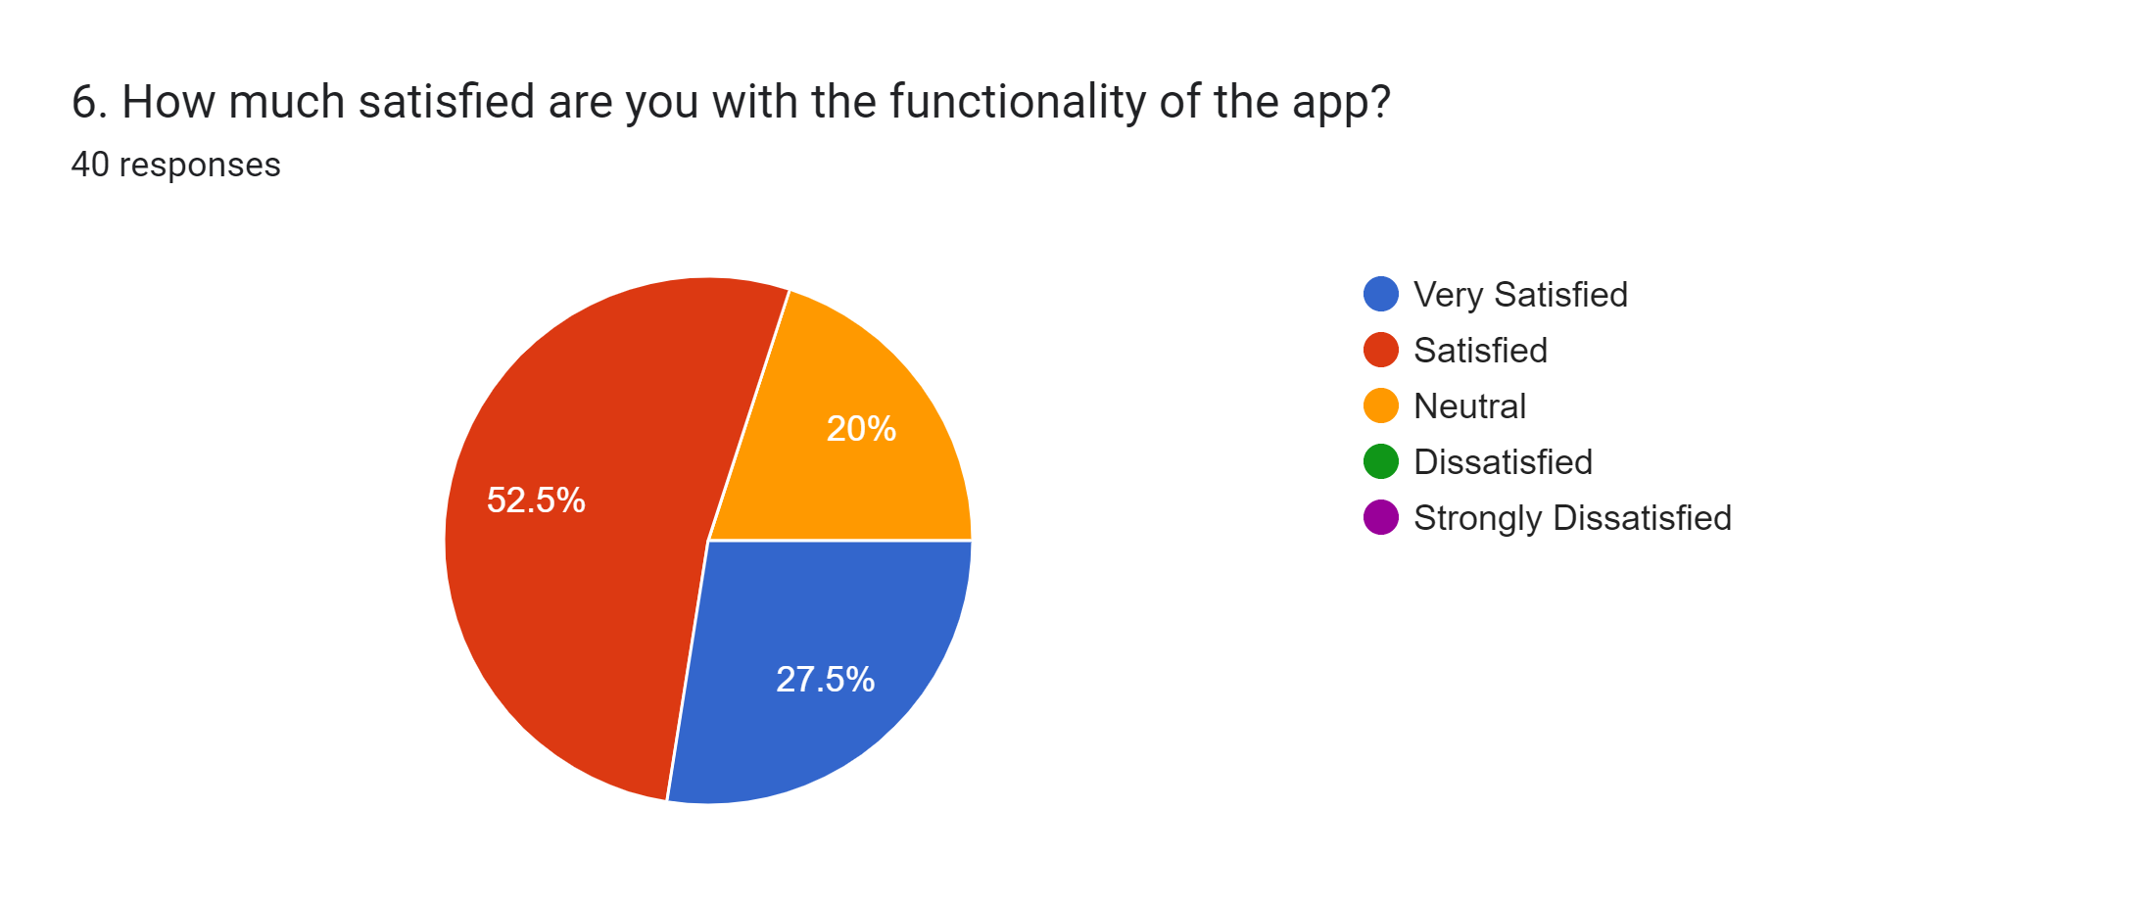



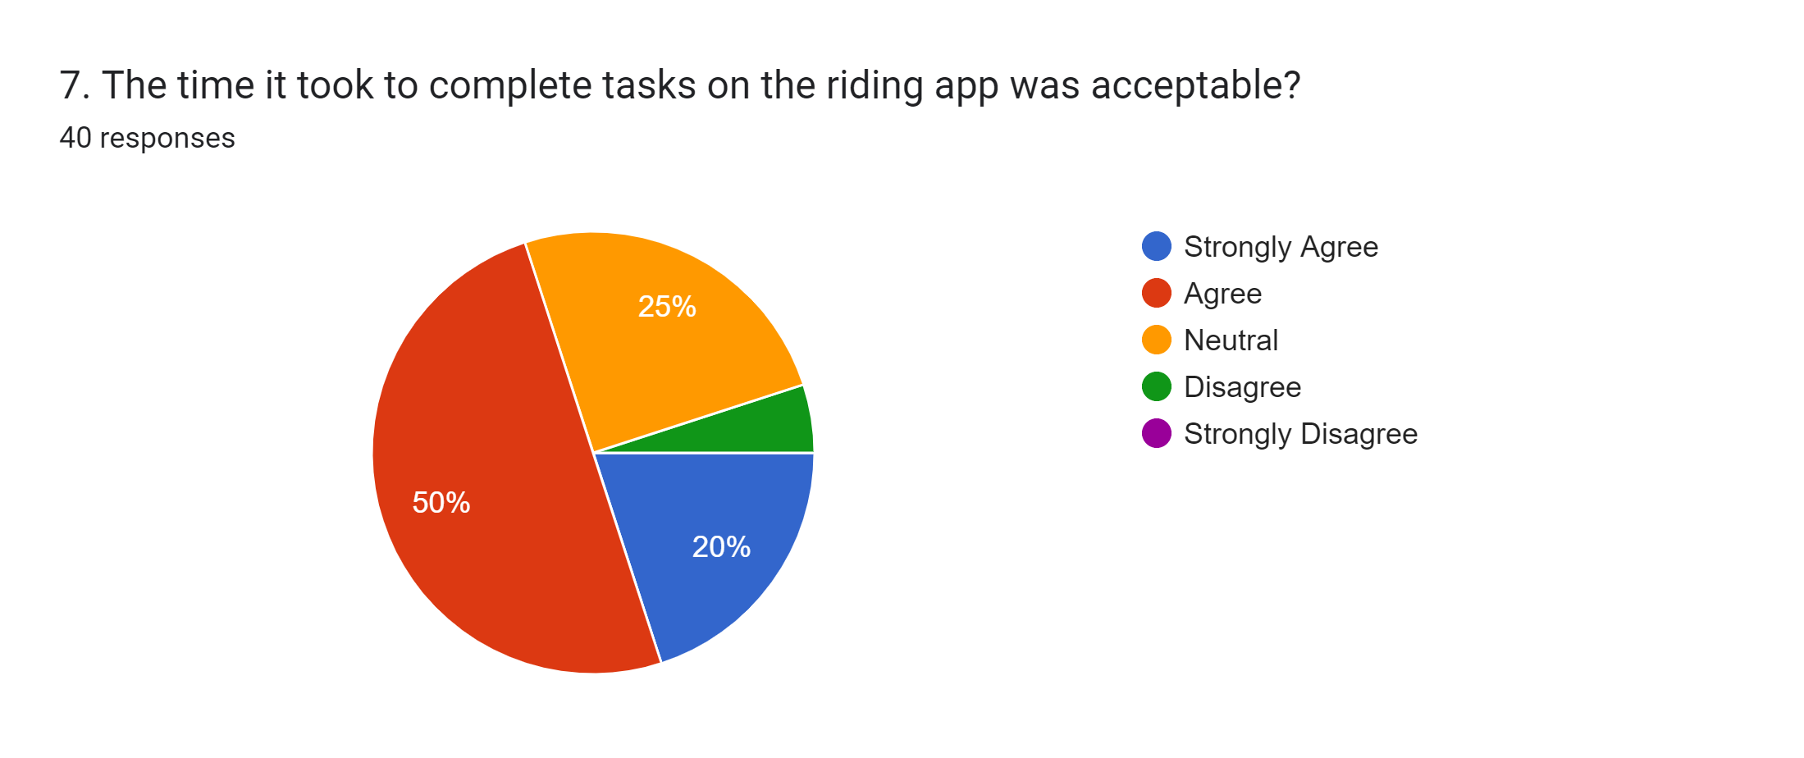

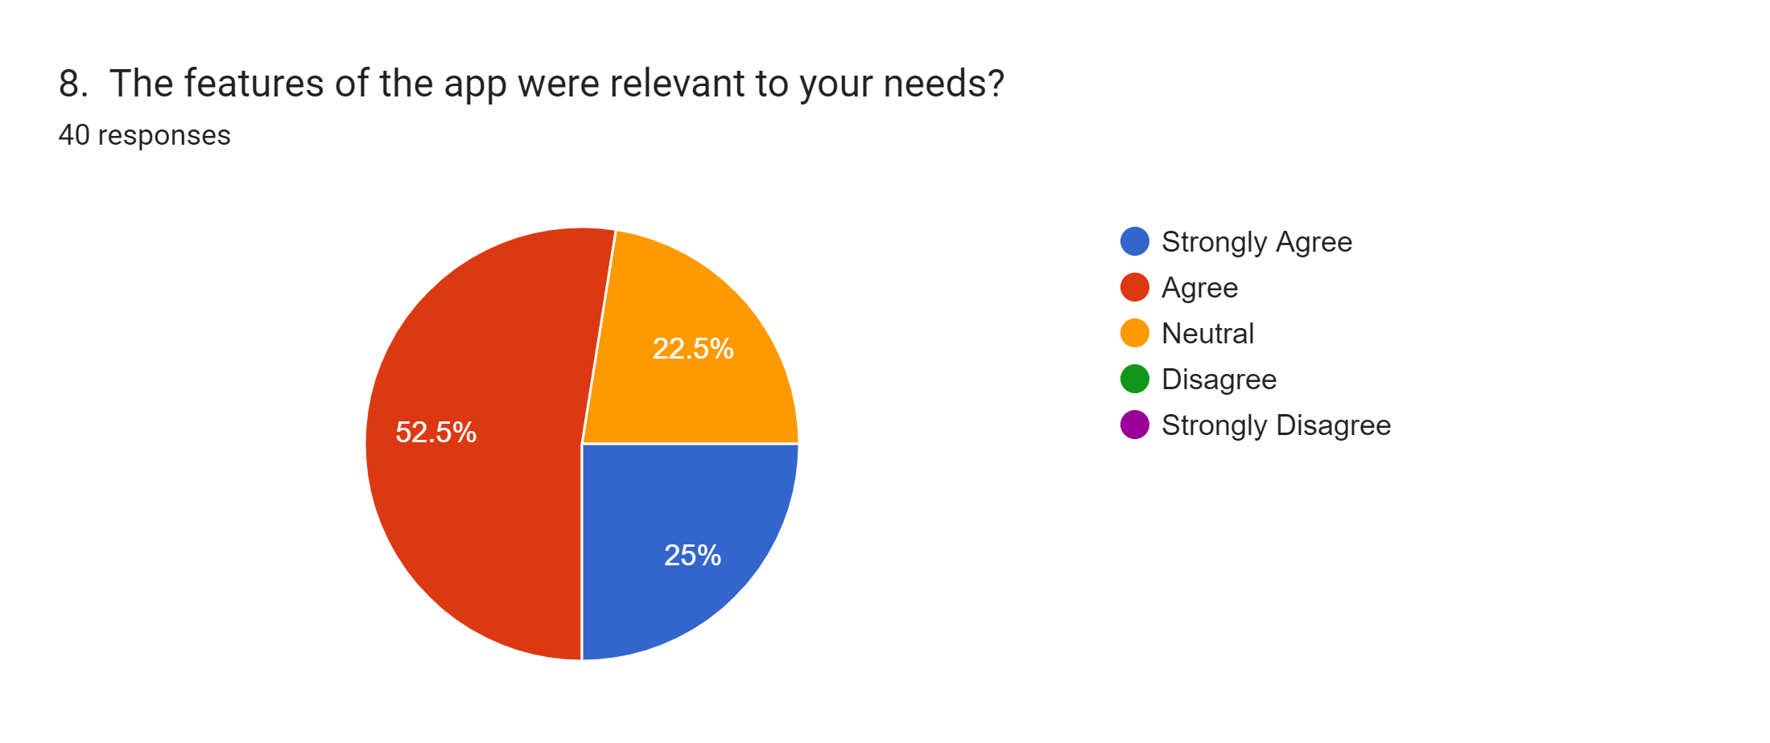



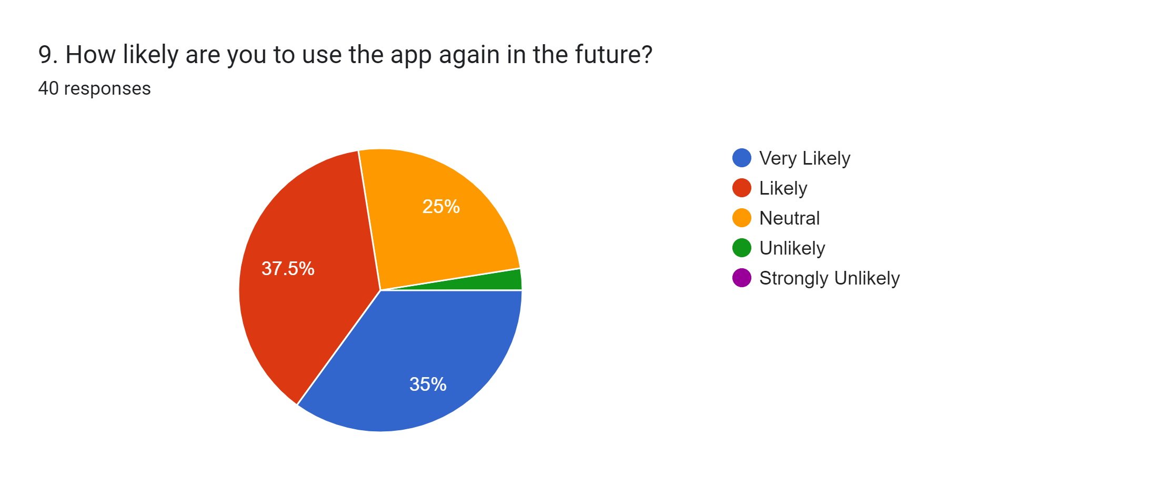

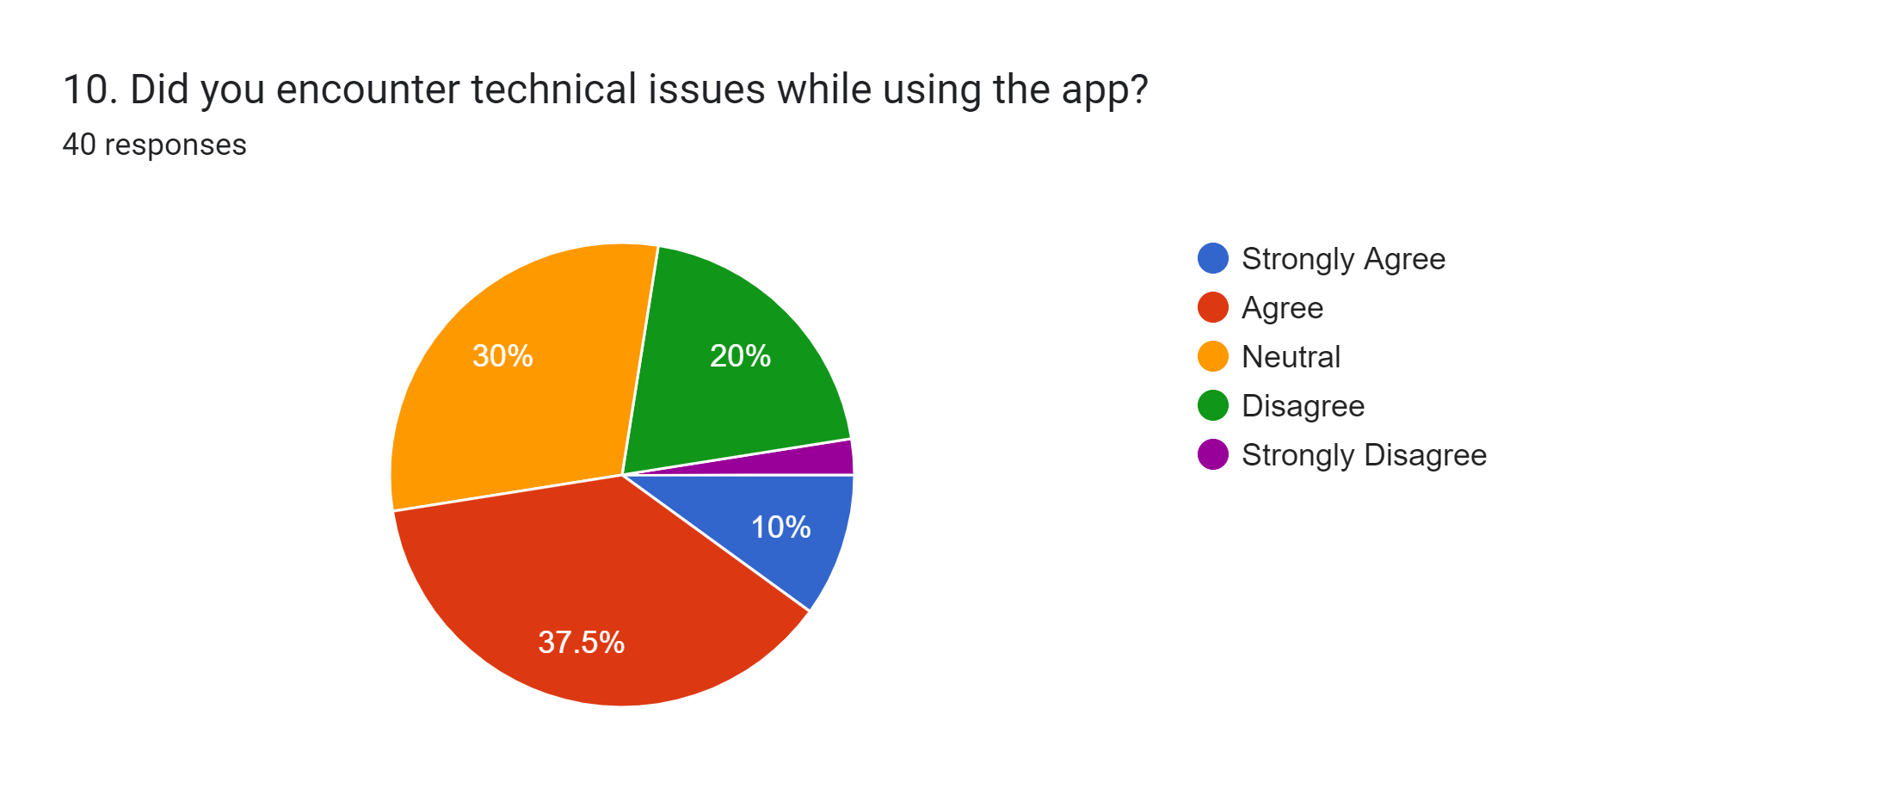



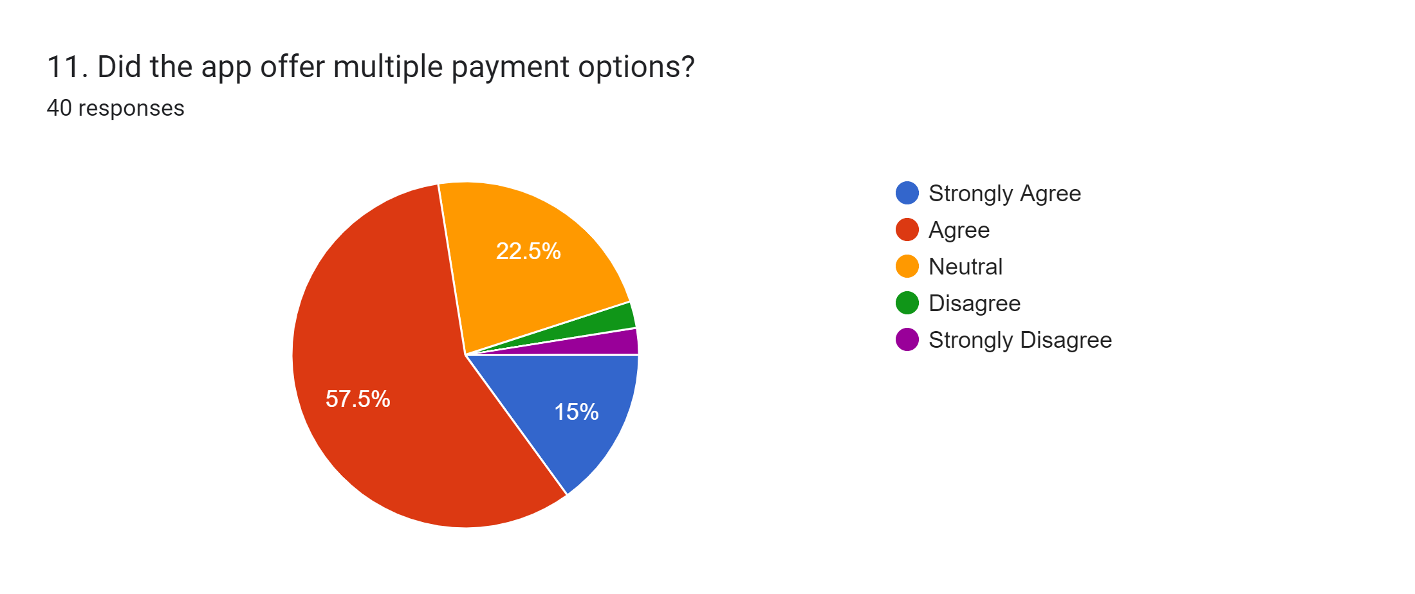

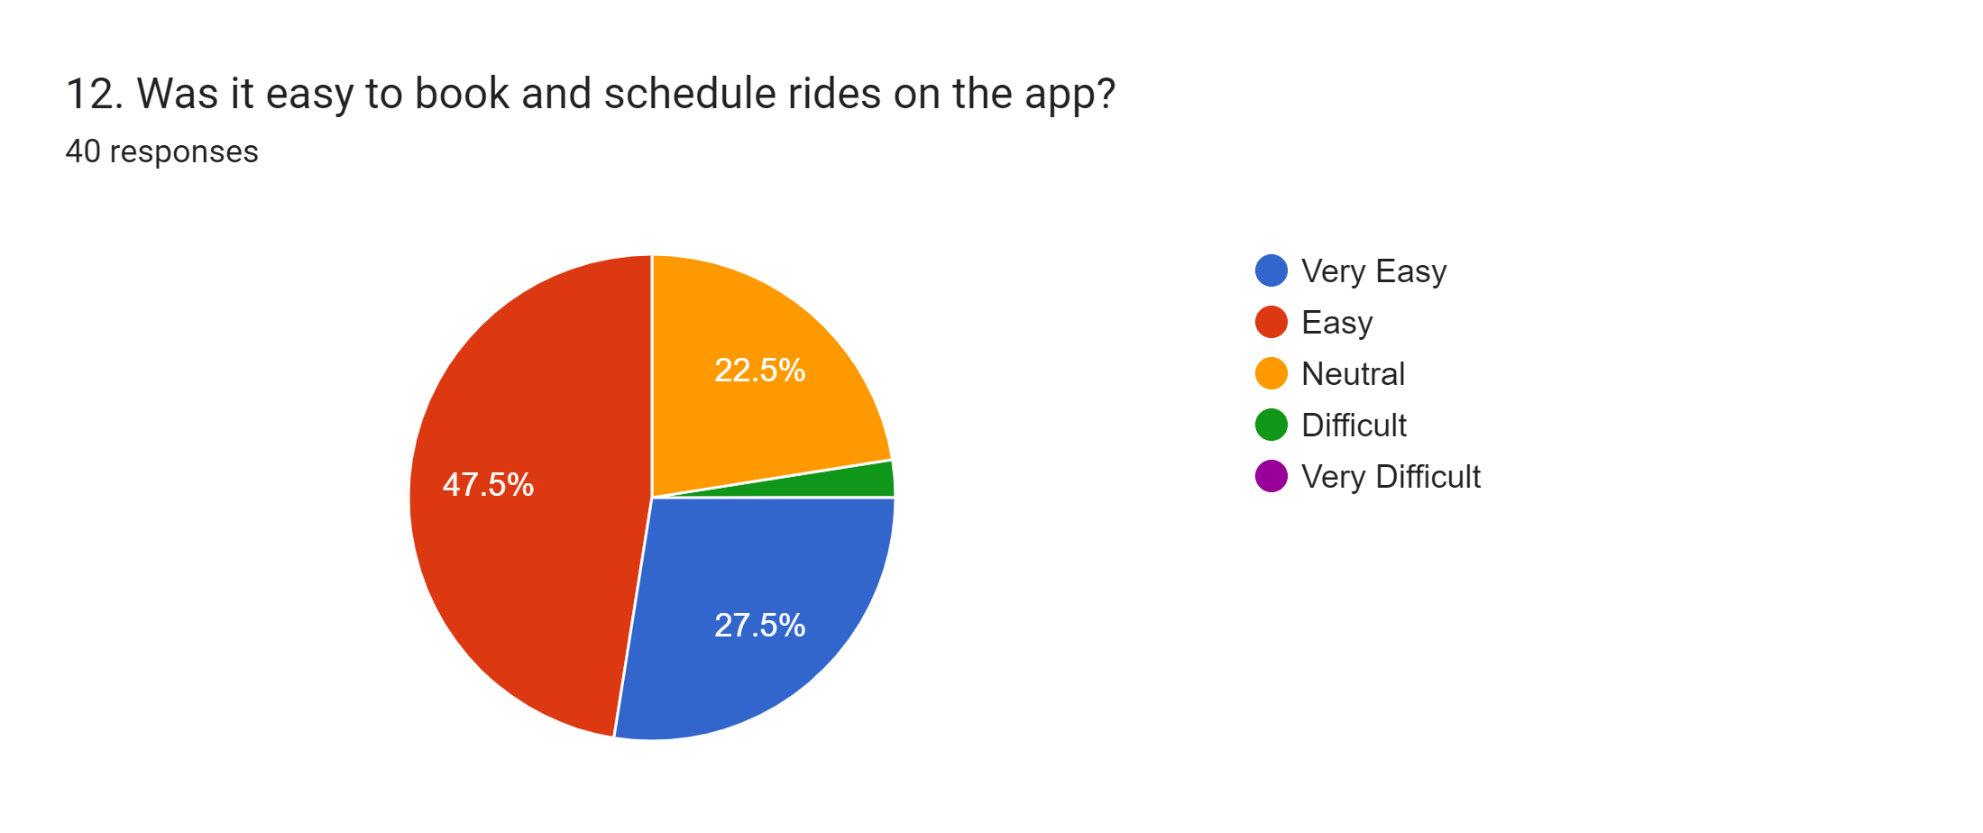



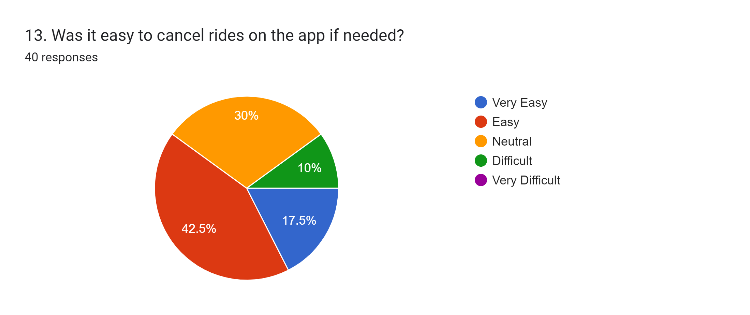

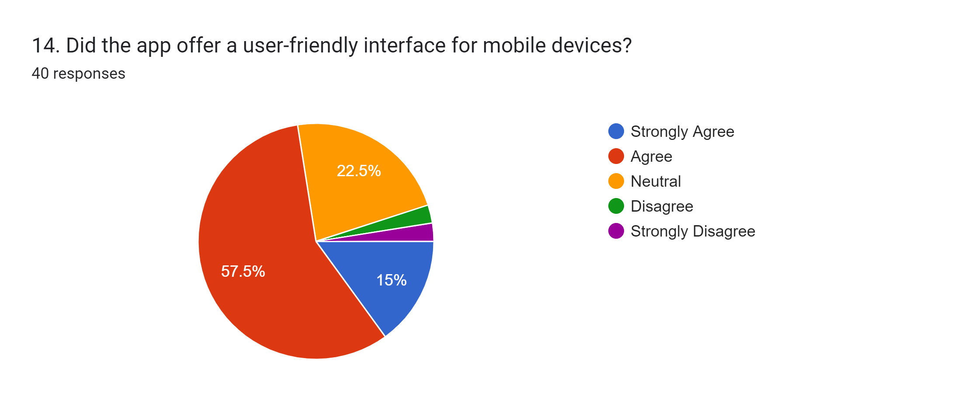



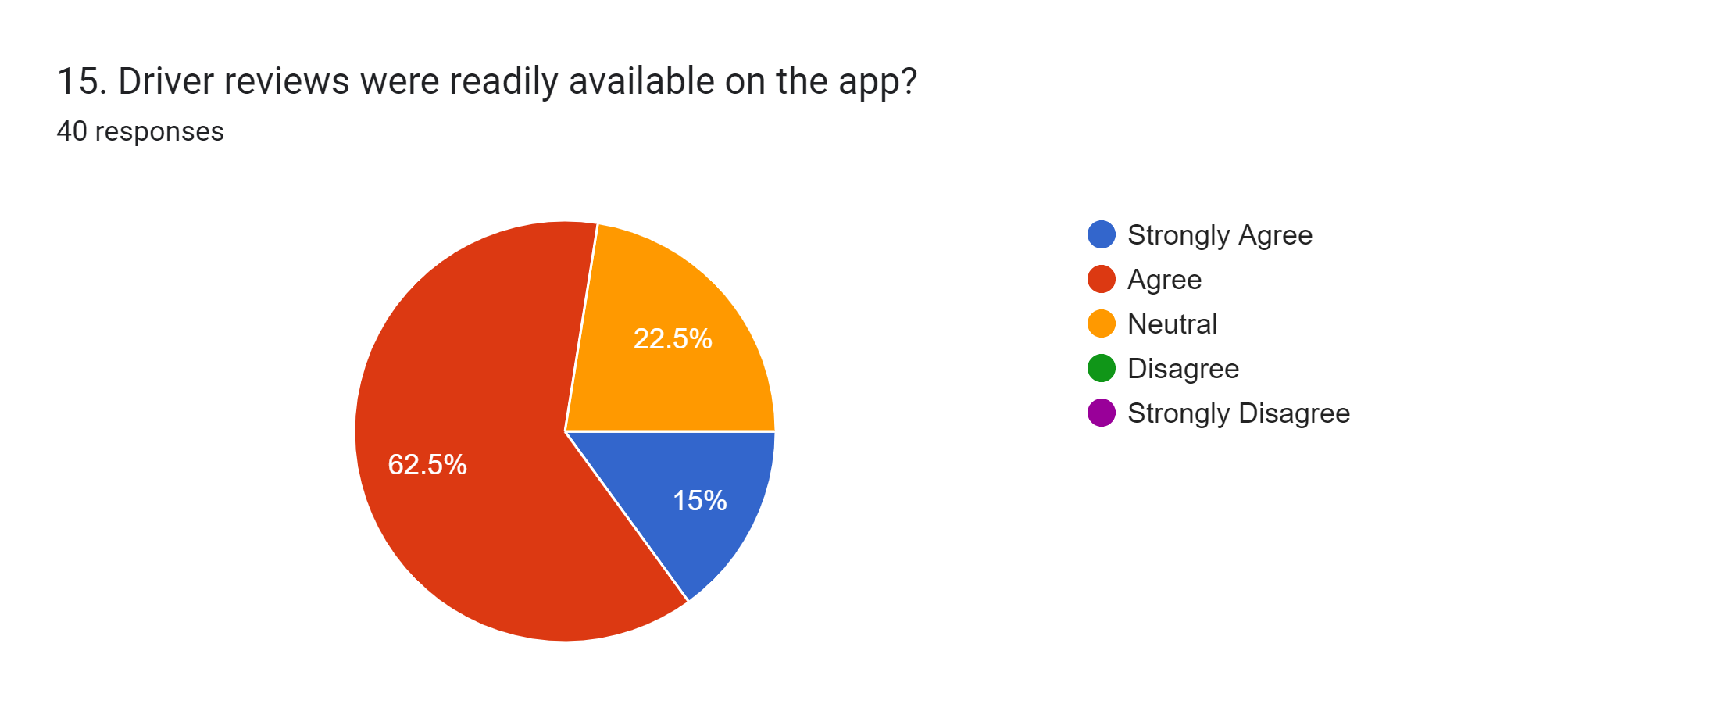



























**Question.6**

**Norman Interaction Models**

**Norman's model of interaction can be applied to ride-hailing apps like Uber/InDriver in several ways. Here are a few examples:**

**Forming the goal** . The first step in Norman's model is for the user to form the goal of their interaction. In the case of a ride-hailing app, the user's goal might be to book a ride to a specific location, or to find a ride that is shared with other passengers.

**Specifying an action.** Once the user has formed their goal, they need to specify an action that will help them achieve that goal. In the case of a ride-hailing app, the user might specify an action by entering their pick-up and drop-off locations, or by selecting a ride option from a list.

**Executing the action.** The next step is for the user to execute the action that they have specified. In the case of a ride-hailing app, this might involve tapping a button to book a ride, or swiping through a list of ride options.



**Perceiving the state of the world.** Once the user has executed the action, they need to perceive the state of the world to determine whether their goal has been achieved. In the case of a ride-hailing app, the user might perceive the state of the world by seeing a confirmation message that their ride has been booked, or by seeing a list of nearby drivers who are available to provide a ride.

**Interpreting the state of the world.** The user then needs to interpret the state of the world to determine whether their goal has been achieved. In the case of a ride-hailing app, the user might interpret the state of the world by understanding that their ride has been booked, or by understanding that there are no nearby drivers who are available to provide a ride.

**Evaluating the outcome.** Finally, the user needs to evaluate the outcome of their interaction to determine whether they were successful in achieving their goal. In the case of a ride-hailing app, the user might evaluate the outcome by determining whether their ride arrived on time, or by determining whether the ride was comfortable and affordable.



**Question.7**

**Prioritize Requirements**

1. Easy Booking Process and Quick Pickups: Users expect a ride-hailing app to have a user-friendly interface that makes it easy to book a ride. The app should provide the user with real-time information on the availability, location, and estimated time of arrival of the driver.
2. Safety and security: Users need to feel safe when using ride-hailing apps, so security features should be the top priority. This includes verifying driver licenses, background checks, in-app emergency features, and safety tips for passengers.
3. Easy-to-use interface: The app UI should be intuitive and user-friendly, with easy navigation, clear buttons, and quick access to commonly used features.
4. Flexibility and availability: The app should offer a variety of ride options to meet different needs and budgets, with options such as shared rides, luxury vehicles, and wheelchair-accessible vehicles. It should also be available and accessible 24/7, with quick response times.
5. Cost-effectiveness: Affordability is a significant factor for users, so the ride-hailing app should be cost-effective and transparent, with clear pricing, cancellation fees, and surge pricing alerts.
6. Reliable and efficient service: Users need to rely on their ride-hailing app to get where they need to go on time. The app should have reliable drivers, drivers with high ratings, and timely pickup and drop-off timings.
7. Personalization and customization: Users want an app that can personalize their experience based on their preferences, such as preferred destinations, preferred routes, and vehicle type.
8. Integration with other services: The ride-hailing app should integrate with other services, such as payment gateways, mapping and navigation apps, and ride-sharing programs, to increase convenience and accessibility.
9. Data privacy and security policies: User data privacy and security should be a top priority for the app. It must be compliant with legal and privacy standards to avoid any legal issues in the future.
10. Efficient Routing and Navigation: The app should have an advanced routing and navigation system to help drivers reach their destination easily and quickly. The system must consider factors such as traffic, road closures, and roadblocks, to ensure that the ride is as smooth as possible.
11. Feedback and Reviews: Users value feedback and reviews from other users. The app should have a system for users to leave feedback and ratings for the driver and the ride, which can help improve the quality of the service and foster trust among users.